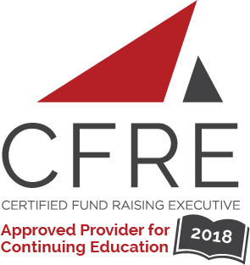  CFRE International has developed this form as a way for you to quickly track (and keep in your files!) the continuing education sessions you have attended. Simply check the boxes next to the sessions you attended. At the end of the conference, add up the total number of hours. Keep this sheet and you will be ready to complete your application form. All of the session slots listed are eligible for continuing education points on your CFRE application for initial certification and/or recertification. Sessions not listed here are not eligible for points. |  | CONTINUING EDUCATION POINTS TRACKER

Activity Organizer: - Xlerate Day
Title of Activity: - Xlerate Day
Names of Presenter(s): - Various
Dates and Location: - November 2, 2018, Toronto, Canada

Date: Friday, November 2, 2018
Session 1: 10:15 [am] – 11:00 [am] (1 pt)
- [Culture Shift: How One Organization Learned to Embrace Digital Advocacy and Integrated Campaigns ... and Have Fun At the Same Time]
- [Harnessing The Power Of Mobile. (No this isn't text to give)]
- [Digital's All Grown Up: What Does Digital Maturity Look Like, A Guidebook for Leadership]
- [Colonial Roots of Fundraising: Unpacking bias And Learning To Ask The Right Questions]

Date: Friday, November 2, 2018
Session 2: 11:15 [am] – 12:00 [pm] (1 pt)
- [Digital Campaigns Explained: Elevating A Canadian Charity’s Digital Marketing Returns]
- [Data-Driven Campaigning, List Building And The Evolving Terrain Of Cell Phones]
- [Why Bother With Truth And Reconciliation In The Non-Profit Sector?]
- [Unaccommodated: Fundraising and Ableism]

Date: Friday, November 2, 2018
Session 3: 1:15 [pm] – 2:00 [pm] (1 pt)
- [Steal The Best Digital Tactics From Political Campaigns—And Use Them For Good!]
- [Data for the Greater Good - Understanding the Digital Donor]
- [Stop Worrying and Collaborate Already!]
- [Building On #Metoo: Bringing An Intersectional And Feminist Lens To The Nonprofit Sector]

Date: Friday, November 2, 2018
Session 4: 2:15 [pm] – 3:00 [pm] (1 pt)
- [Principled And Personalized Digital Work In An Increasingly Crowded Online Space]
- [Future-Proof Your Organization: 5 Ways You Can Prepare For Success And Protect Against Failure]
- [The 10% rule is gone. Now what?]
- [From Egerton Ryerson to the TRC: A Journey Towards Decolonizing A Major University]

Date: Day Month, 2018
Plenary: 3:15 [pm] – 4:00 [pm] (1 pt)
- [Breaking The Mold: Moving Digital Communications From The Individual To The Infinite]

Total number of points attained:

__________

